**Assignment 2**

Write code that performs the following functions or that answers the question. Feel free to do this in R, then copy + paste your code into the assignment turn in space.

1. **DNase** is an R built-in dataset (similar to sleep that we talked about in class). This dataset contains results from an ELISA assay for the recombinant protein DNase in rat serum.

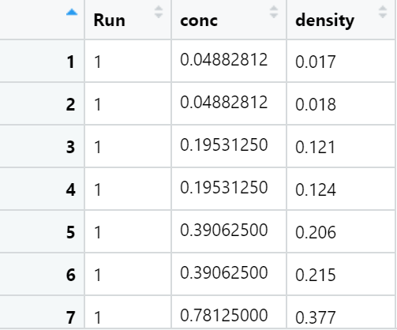

|  |  |  |
| --- | --- | --- |
| **Column name** | **Description** | **Possible values** |
| Run | Assay run number | 1, 2, …, 10, 11 |
| conc | Protein concentration | Numeric |
| density | Optical density | Numeric |

The column conc stands for concentration. You want to do an experiment that requires concentration to be at least 0.4. Create variable **q1** which will store a vector. This vector will have value 0 for every conc value below 0.4, and 1 for every conc value at least 0.4.

1. For how many measurements was concentration at least 0.4? Hint: sum(vector) adds up all the values in the vector parameter. Store answer in **q2**.
2. If your answer to question 2 is over 100, print “Enough concentration values to do my experiment.” Otherwise, print “Not enough data.” Use conditionals to do this.